16.52: (a) The length of the string is 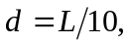 so its third harmonic has frequency 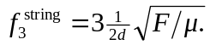The stopped pipe has length L, so its first harmonic has frequency 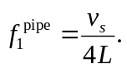 Equating these and using 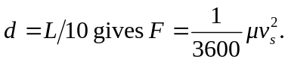
(b) If the tension is doubled, all the frequencies of the string will increase by a factor of . In particular, the third harmonic of the string will no longer be in resonance with the first harmonic of the pipe because the frequencies will no longer match, so the sound produced by the instrument will be diminished.
(c) The string will be in resonance with a standing wave in the pipe when their frequencies are equal. Using 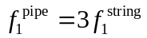, the frequencies of the pipe are 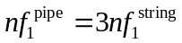, (where n=1, 3, 5…). Setting this equal to the frequencies of the string 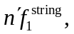 the harmonics of the string are 